# **Cross Validation in Machine Learning**

In machine learning, we couldn’t fit the model on the training data and can’t say that the model will work accurately for the real data. For this, we must assure that our model got the correct patterns from the data, and it is not getting too much noise. For this purpose, we use the cross-validation technique.

**Cross-Validation**

Cross-validation is a technique in which we train our model using the subset of the data-set and then evaluate using the complementary subset of the data-set.

The three steps involved in cross-validation are as follows :

1. Reserve some portion of sample data-set.
2. Using the rest of the dataset, train the model.
3. Test the model using the reserve portion of the data-set.

**Methods of Cross Validation**

**Validation**

In this method, we perform training on the 50% of the given data-set and the rest 50% is used for the testing purpose. The major drawback of this method is that we perform training on the 50% of the dataset, it may be possible that the remaining 50% of the data contains some important information which we are leaving while training our model i.e higher bias.

**LOOCV (Leave One Out Cross Validation)**

In this method, we perform training on the whole data-set but leaves only one data-point of the available data-set and then iterates for each data-point. It has some advantages as well as disadvantages also.

An advantage of using this method is that we make use of all data points and hence it is low bias.

The major drawback of this method is that it leads to higher variation in the testing model as we are testing against one data point. If the data point is an outlier it can lead to higher variation. Another drawback is it takes a lot of execution time as it iterates over ‘the number of data points’ times.

**K-Fold Cross Validation**

In this method, we split the data-set into k numbers of subsets(known as folds) then we perform training on all the subsets but leave one(k-1) subset for the evaluation of the trained model. In this method, we iterate k times with a different subset reserved for testing purposes each time.

***Note:***

It is always suggested that the value of k should be 10 as the lower value of k takes towards validation and higher value of k leads to LOOCV method.

**---------------X-----------------------X-**

The example given below can be left out at this stage of this course.

It can be picked up again when the time comes to apply machine learning models on a dataset. The student will be able to grasp the concept better then.

---------------------------------------

**Example**

The diagram below shows an example of the training subsets and evaluation subsets generated in k-fold cross-validation. Here, we have a total of 25 instances. In first iteration we use the first 20 percent of data for evaluation, and the remaining 80 percent for training([1-5] testing and [5-25] training) while in the second iteration we use the second subset of 20 percent for evaluation, and the remaining three subsets of the data for training([5-10] testing and [1-5 and 10-25] training), and so on.

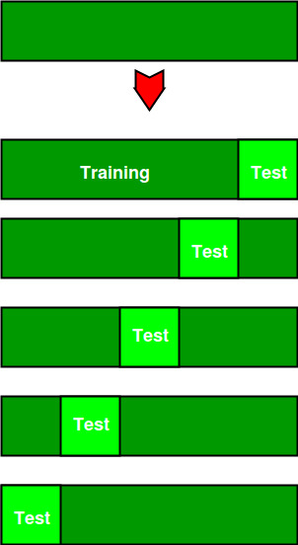

Total instances: 25

Value of k : 5

No. Iteration Training set observations Testing set observations

1 [ 5 6 7 8 9 10 11 12 13 14 15 16 17 18 19 20 21 22 23 24] [0 1 2 3 4]

2 [ 0 1 2 3 4 10 11 12 13 14 15 16 17 18 19 20 21 22 23 24] [5 6 7 8 9]

3 [ 0 1 2 3 4 5 6 7 8 9 15 16 17 18 19 20 21 22 23 24] [10 11 12 13 14]

4 [ 0 1 2 3 4 5 6 7 8 9 10 11 12 13 14 20 21 22 23 24] [15 16 17 18 19]

5 [ 0 1 2 3 4 5 6 7 8 9 10 11 12 13 14 15 16 17 18 19] [20 21 22 23 24]

**Comparison of train/test split to cross-validation**

Advantages of train/test split:

1. This runs K times faster than Leave One Out cross-validation because K-fold cross-validation repeats the train/test split K-times.
2. Simpler to examine the detailed results of the testing process.

Advantages of cross-validation:

1. More accurate estimate of out-of-sample accuracy.
2. More “efficient” use of data as every observation is used for both training and testing.

Python code for k fold cross-validation.

| # This code may not be run on GFG IDE  # as required packages are not found.    # importing cross-validation from sklearn package.  from sklearn import cross_validation    # The value of K is 10.  data = cross_validation.KFold(len(train_set), n_folds=10, indices=False) |
| --- |